**PRACTICAL - 2**

**AIM: Demonstrate the configuration of VLAN (Virtual LAN) using cisco packet tracer**

**THEORY:**

**VIRTUAL LAN - It is a subnetwork which can group together collections of devices on separate physical local area networks**

**A VLAN is any**[**broadcast domain**](https://en.wikipedia.org/wiki/Broadcast_domain)**that is**[**partitioned**](https://en.wikipedia.org/wiki/Network_segmentation)**and isolated in a**[**computer network**](https://en.wikipedia.org/wiki/Computer_network)**at the**[**data link layer**](https://en.wikipedia.org/wiki/Data_link_layer)**. VLANs work by applying tags to network frames and handling these tags in networking systems. VLANs allow**[**network administrators**](https://en.wikipedia.org/wiki/Network_administrator)**to group hosts together even if the hosts are not directly connected to the same**[**network switch**](https://en.wikipedia.org/wiki/Network_switch)**.**

**Advantages of VLAN**

* **Performance**
* **Formation of virtual groups**
* **Security**
* **Flexibility**
* **Cost reduction**

**TOPOLOGY:**

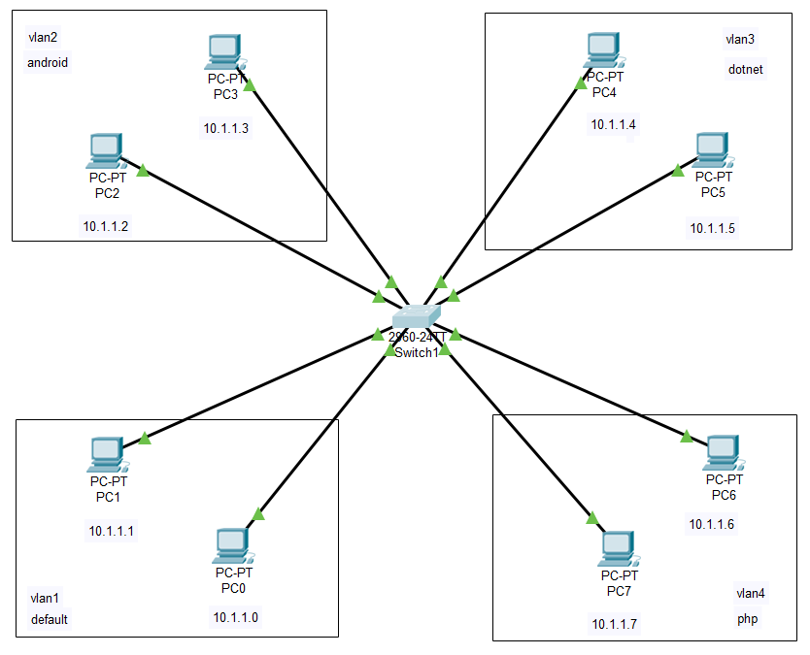

**STEPS OF CONFIGURATION**

**First, we need to create the topology. So, click on the devices and drop on workplace and connect all the devices with the necessary cables**

1. **Configure the Switch using CLI**
2. **Click on switch and then go to the CLI tab**
3. **To get in to the configuration mode, write switch > enable**
4. **To configure the terminal, write switch # configure terminal**



1. **Now enter the vlan number and vlan name to create different virtual LANS**
2. **To create vlan, write switch(config) #vlan 2**
3. **To give name to vlan, write switch(config-vlan) #name android**
4. **To exit (config-vlan), write #exit & repeat the steps for other vlans**

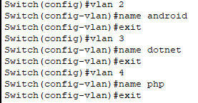

1. **Now, to get into fastEthernet, write #interface fastEthernet 0/3**
2. **To provide access to vlan 2, write #switchport access vlan 2 & repeat steps for other vlans**

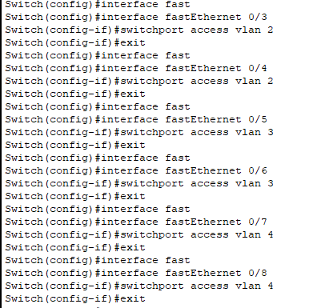

1. **And now to see all the details of vlans, write #show vlan**

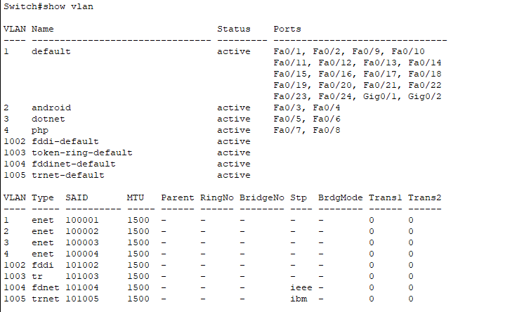

**Provide IP address to all the PC connected in LAN**

1. **Click on PC, go to Desktop tab in that IP Configuration option**
2. **Provide IP address and Subnet mask**
3. **Provide IP Address to All for PC as 10.1.1.0, 10.1.1.1, 10.1.1.2, 10.1.1.3, 10.1.1.4….10.1.1.7**

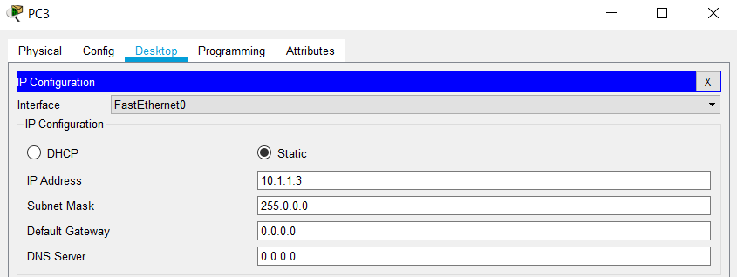

**CHECK NETWORK TOPOLOGY**

* **To check the connections are working properly or not drop one package on the one PC of a vlan and receive it from the other PC of same vlan**

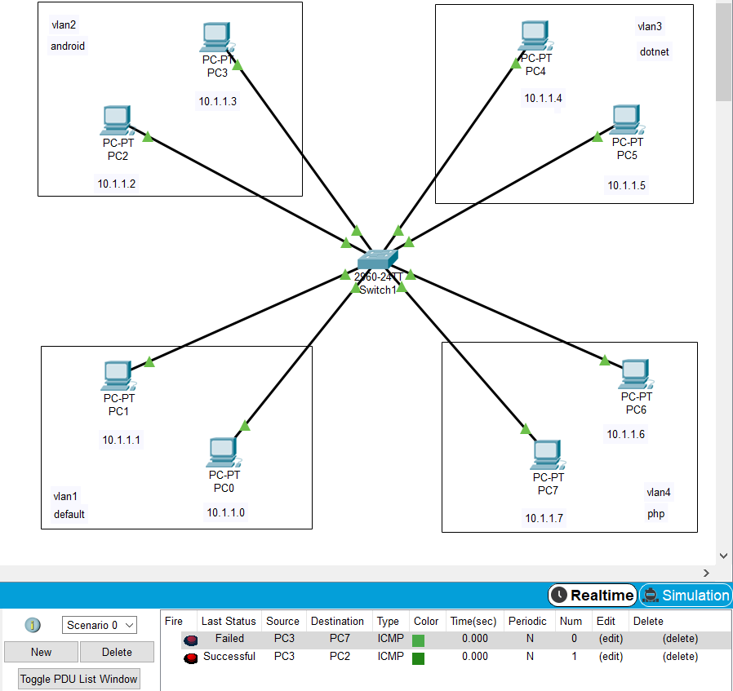

**FAILED – PC3 (vlan 2) to PC7 (vlan4)**

**SUCCESSFUL – PC3 (vlan2) to PC2 (vlan2)**

* **Checking Network Topology using PING command**

**Here I have opened Command prompt of PC5 (vlan3)**

**ping 10.1.1.1 (vlan1) – Requested Timed Out**

**ping 10.1.1.4 (vlan3) – Got reply from 10.1.1.4**

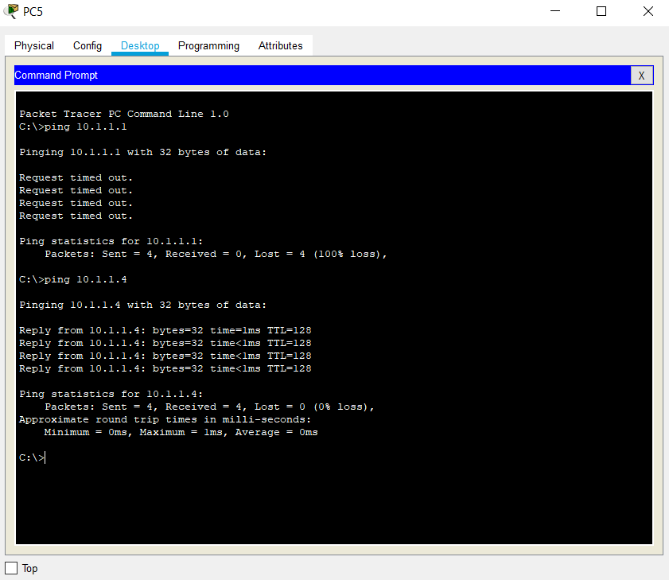

**CONCLUSION:**

From this practical, I learnt about VLAN, how to create different VLAN and connect different fastEthernet to VLAN. Also, I was able to understand that and how to configure the switch with the help of CLI.